
Environmental Management System: Worksheets

Created by Sustainability Team


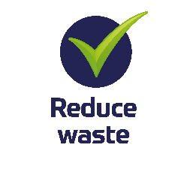
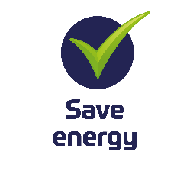
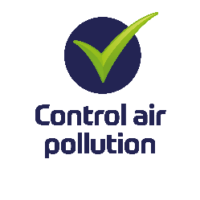
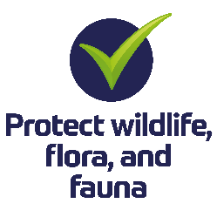




Contents
Introduction 3
WORKSHEET 1 - ENVIRONMENTAL BENEFITS 4
WORKSHEET 2 - ORGANISATION STRUCTURE 6
WORKSHEET 3 - POLICY STATEMENT 7
WORKSHEET 4 - ENVIRONMENTAL INTERACTIONS 9
WORKSHEET 5 - ENVIRONMENTAL ASPECTS AND IMPACTS 12
WORKSHEET 6 – DESIRE STATE OF SUSTAINABILITY 14
WORKSHEET 7 - ACTION ON ASPECTS AND IMPACTS 15
WORKSHEET 8 - GOAL, OBJECTIVES & ACTION PLAN 18
WORKSHEET 9 – ACTION ALREADY UNDERTAKEN 19
WORKSHEET 10 - COMMUNICATION PLAN 20
Other Areas to Consider: 21
External Resources 22

Introduction
Introduction
This worksheet has been designed to support Motorsport UK members, clubs, and event organisers in creating a practical and realistic Environmental Management System (EMS). The EMS is based upon the FIA Environmental Programme, which aims to increase awareness and promote best practice in environmental management across the motorsport community.
This worksheet can be completed with your committee, senior management team, or organising committee. Together, they will provide the tools needed to prepare your environmental policy statement, identify the environmental aspects and impacts of your activities, set environmental goals and objectives, and manage the implementation and operation of your EMS.
The FIA has defined seven core principles of environmental management:
- Leadership & Organisation
- Objectives and Targets
- Communication, Training and Consultation
- Compliance
- Measurement & Monitoring
- Documentation and Auditing
- Managing Environmental Impacts
The FIA Best Practice Environmental Framework covers ten key environmental impact areas:
- Energy Use
- Water Use
- Waste Management
- Ground and Water Pollution Control
- Materials and Design
- Transport
- Biodiversity and Heritage
- Noise
- Air Quality
- Carbon Management
In the longer term, the FIA envisage that stakeholders wishing to conduct major motorsport activities will be required to be accredited against this best practice framework. The information provided in this worksheet, the online module, and the example will guide you in developing your EMS to align with the FIA’s standards—equivalent to Stage 1 of the Best Practice Principles.

WORKSHEET 1 - ENVIRONMENTAL BENEFITS
Sports across all sectors and of all sizes can have a huge impact on the world around us with damage to the environment through waste, pollution, and general lack of duty of care and environmental awareness.
It is our responsibility not only to ensure the success and safety of our sport but also to minimise the environmental impact to the natural environment, reduce air pollution and noise, control energy consumption, reduce the use of natural resources, and reduce waste and refuse.
Please note that not all sections will apply to every situation, and it is acceptable to use 'Not Applicable (N/A)' where appropriate. However, be aware that this may be challenged.

Below, you’ll find a template filled with examples in green to illustrate how tasks can be completed and how questions might be answered. Keep in mind that the details will vary depending on your club and discipline, so be sure to tailor it to suit your specific needs.

Exercise: Consider the benefits below and comment in the box provided on how this may impact favourably upon your organisation and its activities.
Environment & Sustainability Programme – Environmental benefits to your club/event
Environmental Benefit | How will this benefit your club or event? (Choose what is relevant)
Waste reduction
Reduction in air pollution

Reduction in energy consumption

Protection of the natural environment, plants, trees, watercourses, animals, insects, fish.

Recycling and use of recycled materials

Responsible waste – e.g. tyre management

Reduction in pollution to land (fuel spills, etc.)

Reduction in land erosion

Noise reduction

Improvement in public image

Verification of compliance with environmental legislation
Minimise financial losses and reduce costs
Have in place a programme of continuous improvement

WORKSHEET 2 - ORGANISATION STRUCTURE
Top level commitment is essential for the success of the Environmental Management System.
A dedicated person should be appointed as the designated Environmental Champion; they will be responsible for the identification and implementation of key environmental initiatives. The Environmental Champion will be responsible for ensuring that the environmental management system (EMS) is in place, that it continues to be practical and realistic, and to ensure that top team/club committee know what is happening in order that they can reset priorities, adjust resources, and amend plans as necessary.
The roles and responsibilities for the successful operation of the EMS should be summarised in an organisation chart.
In addition, specific roles will be allocated to assist the ‘Champion’ in the execution of their duties.
Typical roles in support of the Environmental Champion may related to purchasing or contact with local authorities. Trainers and Club Secretaries, Safety Officers, people dealing with energy and of course, incident control.
It is also important that responsibility is taken for the recording, investigation and reporting of environmental incidents.

Exercise: Complete an organisation chart of to show the roles and responsibilities for environmental management within your club or event organisation team.
Please see further examples included as additional resources on the learning hub.

WORKSHEET 3 - POLICY STATEMENT
An “Environmental Policy” outlines the organisation’s approach to its impact on the environment. This statement must come from your senior team. This is because the policy will affect how every individual performs their role in relation to environmental impact. The Environmental Policy will display what commitments your club/organisation will make to control and improve your events in all aspects regarding the environment.
The senior team must establish, implement, and maintain an Environmental Policy that:
- Suits the purpose and context of the organisation, such as the nature, scale and the environmental impacts of its activities, products, and services
- Provides building blocks for setting environmental goals
- Includes a commitment to the protection of the environment
- Encompasses a pledge to fulfil its compliance obligations
- Consists of a commitment to continual improvement of the EMS to build the environmental performance
The environmental policy must be maintained as documented information, be communicated throughout the organisation and be available to stakeholders and interested parties.
The policy should be reviewed on an annual basis by means of management review and updated if required.
This is a great opportunity to highlight what your club stands for and its approach to environmental matters. Keep it simple and concise—ideally no more than one page—so it’s easy for stakeholders to understand. Many organisations have an environmental policy and below is a list of examples from other clubs to help guide you.
- Motorsport UK
- Vintage Sports Car Club
- Bath Motor Club
- Border Ecosse Car Club

Complete the environmental policy template with the appropriate details of your organisation and get your most senior manager to sign and date it.
Environment & Sustainability Programme – Policy Statement

Club/Event Name and Logo

Over-arching statement of intent
Club/Event name is committed to protecting local and global environment as impacted by its activities, events, and actions.

To minimise environmental impacts and to promote sustainability we will:
- Comply with applicable legal requirements which relate to our environmental aspects.
- Include the consideration of environmental issues in our club/events strategies and initiatives.
- Club/Event name senior management are committed to ensure that protection of the environment is firmly embedded in the culture of the club/event.
- Prevent pollution, reduce waste, and minimise the consumption of resources.
- Consider the wider global impact of all our activities including those of our suppliers and sub-contractors
- Educate, train, and motivate our teams, competitors, officials and volunteers to be environmentally responsible.
- Take action to prevent pollution, protect the ecosystem, biodiversity, management of natural resources, wildlife, and ancient species. Encourage and enhance biodiversity and ecology.
- Implement an energy conservation policy
- Control waste materials and seek opportunities for waste minimization and recycling
- Control of the use of toxic substances
- Control of human activities to ensure protection of the environment
- Practice responsible resourcing.
- Recognise our commitment to the Motorsport UK Environmental Sustainability Programme
The club/event is committed to continual improvement in environment performance.
This policy will be communicated to all staff, club members, competitors, officials, marshals, contractors, and suppliers and be available through public media.

Signed Date

(Name and title of Club President/Event Director)

Updated and amended (remember to re-sign every year with any amends)

Signed Date

WORKSHEET 4 - ENVIRONMENTAL INTERACTIONS
Motorsport UK is committed to creating a sustainable and responsible model for British motorsport. Primarily this is achieved through regulation, for example:
- Acceptable tyres for stage rallying, with treads that limit the damage caused to road surfaces
- Window film is mandated on stage rally cars to minimise the spread of glass if there is an accident
- Mud flaps are required on stage rally cars to keep displaced gravel on the road surface
- The mandatory use of spill kits at all events limits the potential environmental impact of spilt substances.

Motorsport UK regulations also allow for the development of vehicles powered by alternative fuels and technologies, these are permitted to compete on a level playing field with the risk managed appropriately. Technologies developed within motor sport that yield environmental benefits include fuel management and energy recovery systems.
Limiting noise pollution is also extremely important and the Motorsport UK Yearbook details the noise limits for various competition vehicles.
It is important to consider how your club or event interacts with the environment whether through the use of electricity in your club house or the waste management in your paddock/service park. The following section provides a guide to some of the main areas of legislation that may be relevant to you.

Environmental legislation

Main environmental law areas
- Air emissions.
Many activities, from vehicle pollution emissions to complicated industrial processes, affect air quality and can significantly impact human health.
- Mitigation of climate change
Measures can range from renewable energy projects, emission trading schemes, energy efficiency in buildings and the use of electric or low emission cars
- Contamination and pollution.
Land affected by contamination can be a blight on communities and may present unacceptable risks to human health and the environment, including pollution of surface water and groundwater.
- Environmental permits and consents
This is the system that provides that a wide range of commercial and industrial processes require an environmental permit.
- Environmental reporting.
These reporting regimes include streamlined energy and carbon reporting and greenhouse gas reporting
- Waste.
Managing the production and disposal of waste is one of the most significant challenges addressed though environmental law.
Clubs and events produce waste and most types of waste produced are classed as controlled waste. You have a legal responsibility to ensure that you produce, store, transport and dispose of controlled waste without harming the environment. This is called your duty of care.
- Water, flooding, and drainage.
Water pollution law is the most developed of the pollution control systems and is a huge and complex area of environmental law, with numerous laws at international, EU and domestic level.
- Wildlife and habitat conservation.
Nature conservation in environmental law involves the control of land management to seek to conserve, protect and restore habitats for flora and fauna preventing their extinction, reduction, or fragmentation.
- Civil law—nuisance, negligence, and the rule in Rylands v Fletcher.
A person or company who has suffered loss may be entitled to bring a claim for damages in civil law under the common law of nuisance, negligence or the rule in Rylands v Fletcher against those who have caused contamination, pollution or nuisance (https://en.wikipedia.org/wiki/Rylands_v_Fletcher).
- Town and country planning.
Town and country planning plays a vital role in environmental law because of its importance in relation to the location of development and commercial activities, as well the design and form of that development. Planning law can also control damaging activities that are not necessarily subject to other environmental controls (such as light pollution).
- Environmental assessment
The importance of environmental assessment (both environmental impact assessments and strategic environmental assessment) as an environmental law mechanism cannot be overstated. Environmental assessments ensure that information about the likely environmental impacts of developments, plans and programmes is considered before planning applications can be granted and any potential detrimental activity is commenced.
In addition to these areas, there are many other environmental law topics, such as hazardous substances and chemicals, energy efficiency, environmental information.

Exercise: List below how your club/event interacts with the core environmental law areas and ensure you research the legislation that affects your club or event.
Environment & Sustainability Programme – Environmental Laws to consider
Relevant Legislation | Action of relevant legislation

WORKSHEET 5 - ENVIRONMENTAL ASPECTS AND IMPACTS
One of the most important elements when working towards and Environmental Management System is the recognition of the way your activities impact on the environment.
This is a form of environmental assessment, which follows a similar pattern to a health & safety assessment in the identification of hazard and risk. Each factor has an impact, as it poses a risk to your operations rather than to the planet. The level of risk depends on the activities you engage in most frequently.
What are environmental aspects and impacts?
- An environmental aspect is the way the activities of your club or event impact on the environment.
- An environmental impact is a change to the environment. Environmental impacts are caused by environmental aspects and can be negative or positive.
Aspects can be direct and indirect. Direct environmental aspects are associated with the specific activities of your club/organisation itself, over which you have direct control (e.g., how you manage waste). Indirect environmental aspects are how, for example, a contract caterer manages waste at your event.

Below is an example of a simple aspects and impacts assessment.
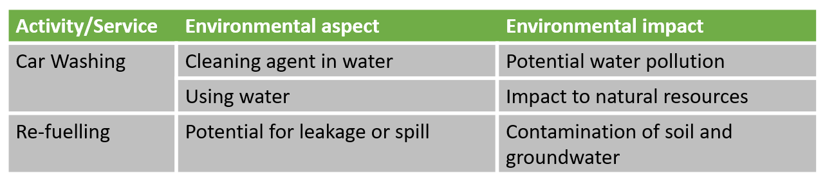

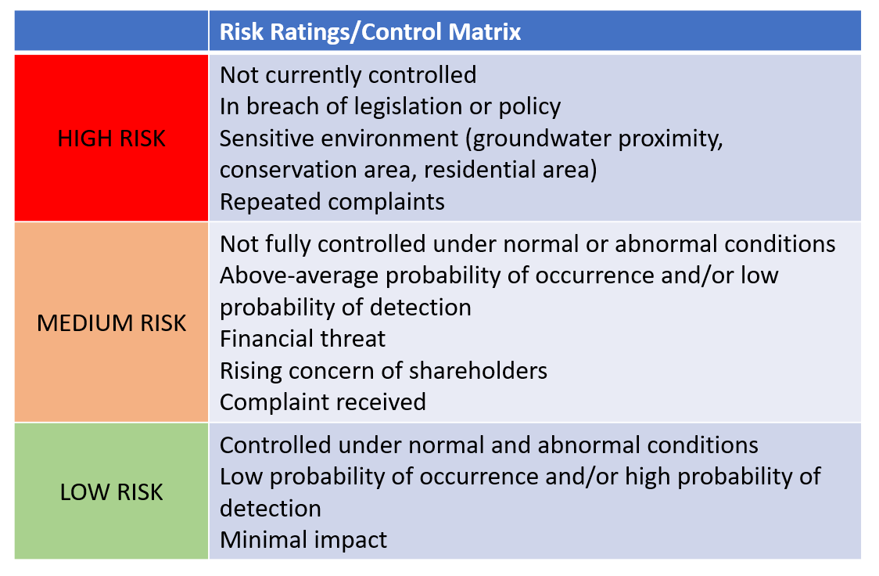

Exercise: List below the primary activities of your club or event and consider the environmental aspects and impacts and the level of harm to the environment.
Environment & Sustainability Programme – Environmental Aspects & Impacts
No. | Activity, Service, Product | Environmental Aspect | Environmental Impact | Level of Impact on the environment
 |  |  |  | High | Med | Low
1
2
3
4
5
6
7
8
9
10
11
12

WORKSHEET 6 – DESIRE STATE OF SUSTAINABILITY
The desired state may be defined as “the way in which we can satisfy the needs of our sport without unnecessary compromise of the environment, so that it remains capable of supporting future generations”. It is about ensuring people recognise and control environmental impacts, manage effective event management systems (to include environmental controls), consideration of the environmental impact of planned and unplanned events and incidents, and clear awareness for all involved in their responsibilities to the environment.
The ‘Desired State’ also relates to resilience and security for future generations. ISO 14001:2015 describe Sustainable Development Goals which assist them in defining their desired state, https://www.iso.org/sdgs.html.


Exercise: Consider what you need to do to achieve the ‘Desired State’ of sustainability in your club/organisation in three years’ time and beyond to 2030. What will your objectives and targets to secure a reduction in your environmental impacts and achieve greater levels of sustainability be? Write a paragraph to explain this.

WORKSHEET 7 - ACTION ON ASPECTS AND IMPACTS
In order to start your sustainability project, you will need an action plan to be clear about the implementation and management of tasks.
Typical steps in creating your action plan are:
- Step 1: Define your Goals for the implementation of the EMS
- Step 2: Secure the senior team’s Commitment.
- Step 3: Select an EMS Champion and support team
- Step 4: Hold a kick-off meeting
- Step 5: Conduct preliminary review
- Step 6: Consider the budget and schedule
- Step 7: Secure resources and assistance
- Step 8: Involve your committee and members
- Step 9: Monitor and communicate progress.

It is advisable to use the Deming or Shewhart ‘PDCA’ cycle of ‘Plan. Do. Check. Act’, four-step, management method used for the control and continuous improvement of the project.

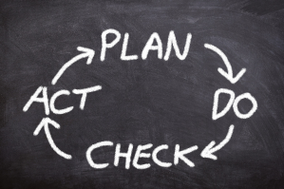

What is your Goal, your overall purpose?
What is your aim or “desired state”? What is it that your club/event can envision and commit to work towards?
With the acknowledgement of the goals, the next step is to clearly target the completion of the goals using the ‘SMART’ approach as follows:
- Specific: Well defined, clear, and unambiguous
- Measurable: With specific criteria that measure your progress towards the accomplishment of the goal
- Achievable: Attainable and not impossible to achieve
- Realistic: Within reach, realistic, and relevant to your organisation.
- Timely: With a clearly defined timeline, including a starting date and a target date.

Specific
The goal should not be generic, but specific.
An example of a generic goal could be the simple statement, ‘We want to be greener’
For a specific goal, the objective should be more specific, ‘We want to implement the Environmental & Sustainability Programme

Measurable
The goal should be quantifiable, what will be the result? How will we measure our success? We need to state what we are wanting as a result. For example, ‘We will achieve ‘FIA Best Practice Principle’ status by 2024’

Achievable
The goal must be achievable and attainable. It must be challenging enough to motivate completion but not too high to decrease the chance of the target being achievable.

Realistic
The target must be realistic. Within the limits and capabilities of the resources available and the amount of work involved.

Timely
A SMART goal must be time-bound in that it has a start and finish date. If the goal is not time constrained, there will be no sense of urgency and motivation to achieve the goal.
Exercise: Now that you’ve outlined your aspects and impacts, it’s time to address the potential negative effects and implement mitigation measures to manage these risks. We encourage you to set a SMART (Specific, Measurable, Achievable, Realistic, Time-bound) target to help assess whether your actions are effectively supporting your sustainability goals. In the next section of the workbook, we ask you to review the impacts listed above and develop a plan to manage them. This plan should aim for long-term objectives that align with your desired sustainability outcomes.
 | Environment & Sustainability Programme – Actions & Impacts
Environmental Impact | Objective | Environmental Action | Target/Measurement | Method of measurement

WORKSHEET 8 - GOAL, OBJECTIVES & ACTION PLAN

Use the following template to create an action plan based on the environmental aspects and impacts as identified in chapter 4 of this workbook and in alignment with your stated goal. This is to achieve short-term goals which will be achieved in the next 3 years before renewal for your sustainability accreditation.

Environment & Sustainability Programme – Specific Objectives and Action Plan
Environment Impact objective | Action | Target.  Measurable  Achievable  Realistic | Owner  Capable  Available | Start date | Finish  Date

WORKSHEET 9 – ACTION ALREADY UNDERTAKEN

Exercise: From the above can you please explain in more detail of what you have already started, please give us 5 examples of how actions so far have supported you in being a more sustainable club.

Environment & Sustainability Programme – Action already undertaken

WORKSHEET 10 - COMMUNICATION PLAN
The key elements for the communication of your EMS are as follows:
- The information given must be policy driven and focused
- Provide all stakeholders with clear, specific information
- Maintain consistency
- Specify who should be given specific information (e.g. the environmental champion)

- Specify when it should be delivered
- Identify what methods will be used

Exercise: Use the following template to create a communication plan about your organisation’s involvement in the Motorsport UK Environmental Sustainability programme
Environment & Sustainability Programme – Communication Plan
Communication | Audience | How does this support you to spread your message | Frequency | Owner

Other Areas to Consider:

Monitoring and Measuring to Achieve Objectives and Monitor Performance
Once we have the action plan in place the next step is to monitor and measure the progress and level of performance towards reaching the goals, followed by an evaluation of the results to determine if the planned programme is working and if not, to consider the potential causes and identify solutions.
There are six steps to the decision process:
- What needs to be monitored and measured e.g. waste?
- What methods are to be used for the measurement e.g. quantity or using bills?
- When the measurements will take place e.g. monthly, annually?
- When will the results be analysed e.g. quarterly?
- Who will make the evaluation of the results, e.g. the environmental team?
- How will the results be communicated, e.g. by meeting / email?
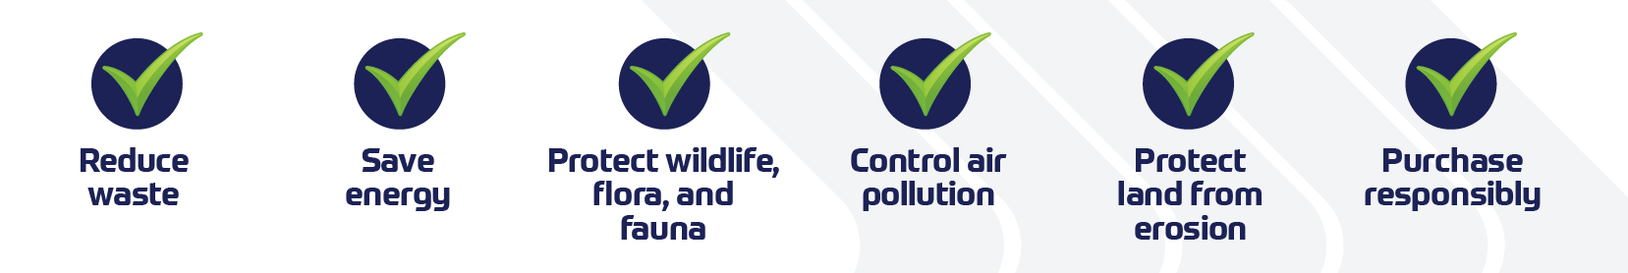

Continuous Improvement in environmental performance.
The previous chapters have identified the stages in the Motorsport UK Environment and Sustainability Programme as it is being rolled out to member clubs and events. All these processes, and the ‘Plan Do Check Act’ approach, lead to the opportunity for continuous improvement, as generally, all of the environmental issues cannot be resolved immediately.
An important part of continuous improvement is checking by auditing, either internally or by external auditors to measure how the organisation is performing against the standard.
This is normally in three phases:
- Preaudit activity- pertaining to collection of information.
- Activity at the location pertaining to evaluation of information collected.
- Post audit activity pertaining to drawing conclusion and identifying areas of improvement if any.
A simple cycle of continuous improvement is a loop of four stages as in the example below:
- Identify the opportunity for improvement, e.g. increase waste recycling by 5%?
- Plan how the current arrangements can be improved, e.g. by greater segregation of waste?
- Implement the changes e.g. by providing more bins for waste segregation?
- Review how the change is working, e.g. by monitoring the waste segregation streams on a regular basis?

External Resources

Documents describing the FIA Best Practice Framework, the Toolkit and Checklists
https://www.fia.com/environmental-accreditation-programme

Motorsport UK Environmental Sustainability
https://www.motorsportuk.org/about-us/environmental-sustainability/

A convenient site listing some of the more important environmental laws in the UK
http://www.field.org.uk/list-of-environmental-laws/

ISO Management Standards
https://www.iso.org/iso-14001-environmental-management.html

Managing health and safety at motorsport events, a guide for motorsport event organisers
https://www.hse.gov.uk/pubns/priced/hsg112.pdf


If you have any questions or issues, please contact the sustainability team:
sustainability@motorsportuk.org
www.motorsportuk.org

